Keycloak Post Setup Guide

Overview
Use this guide after importing the realm to complete the minimum Keycloak setup for ORISO. Follow the steps in order, update URLs for your environment, and assign the required roles and clients to the application user.
1. Log in to Keycloak using your environment URL and admin credentials.

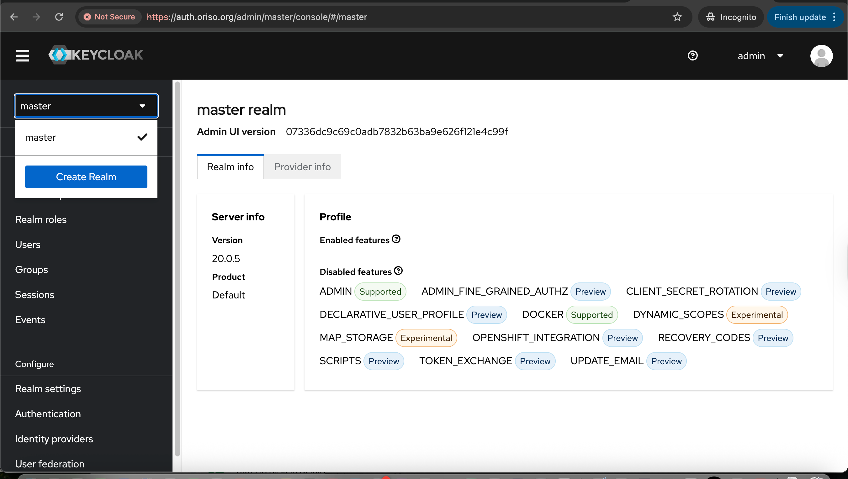
2. After login, open the realm dropdown and select Create realm.

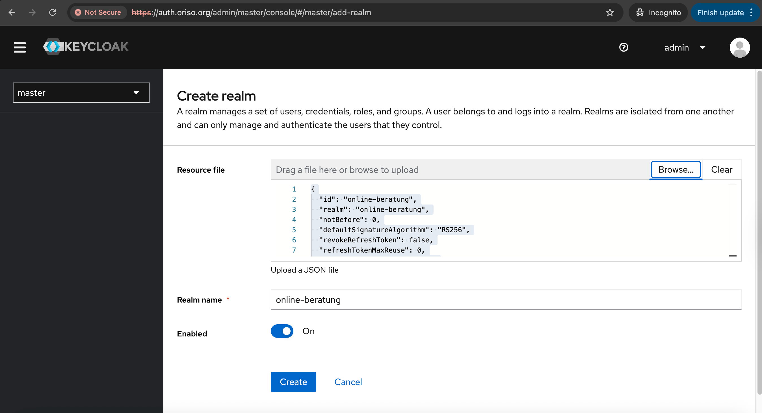
3. Import the realm file from:
ORISO-Kubernetes/keycloak-setup/oriso-realm.json

4. Click Create to finish the realm import.

5. Switch to the online-beratung realm after import completes.
6. Go to Clients -> app -> Settings and update values for your environment:

- Valid redirect URIs
- Web origins
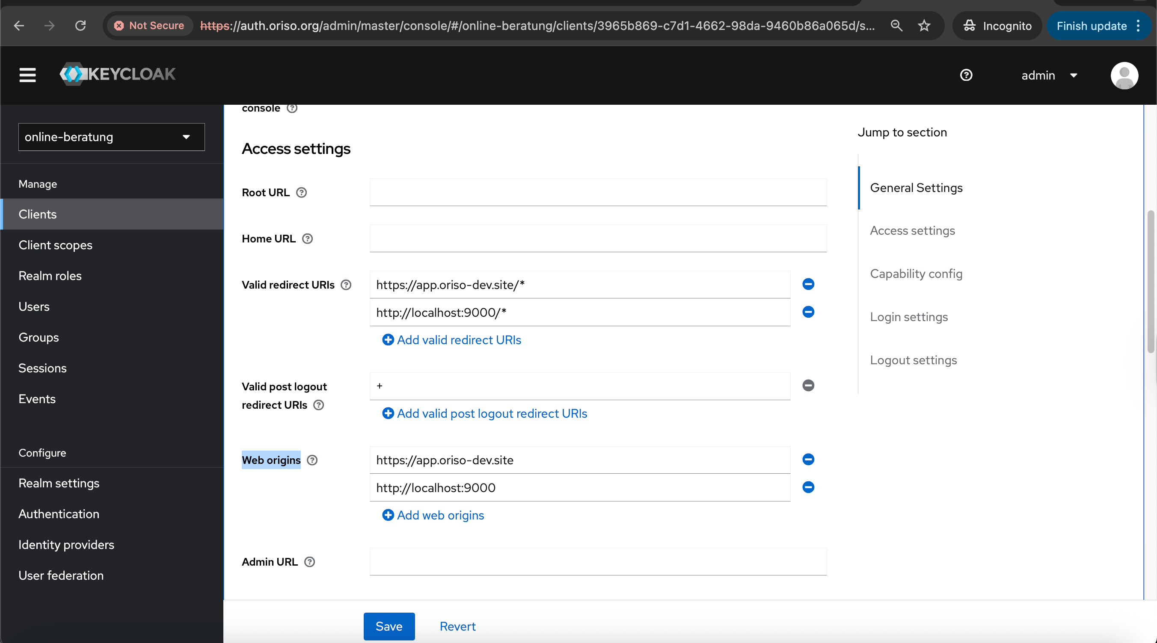

7. Go to Users.
8. Create the user that the application will use.
Example username: Technical

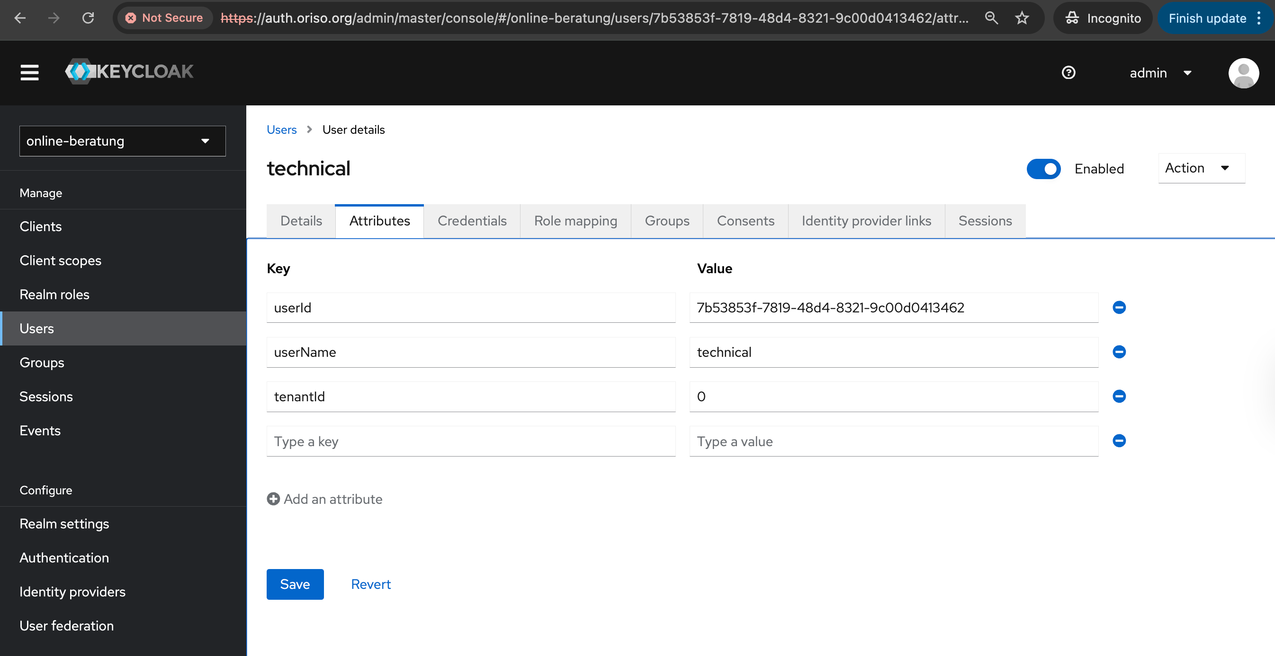
9. Add the minimum user attributes required by the application.

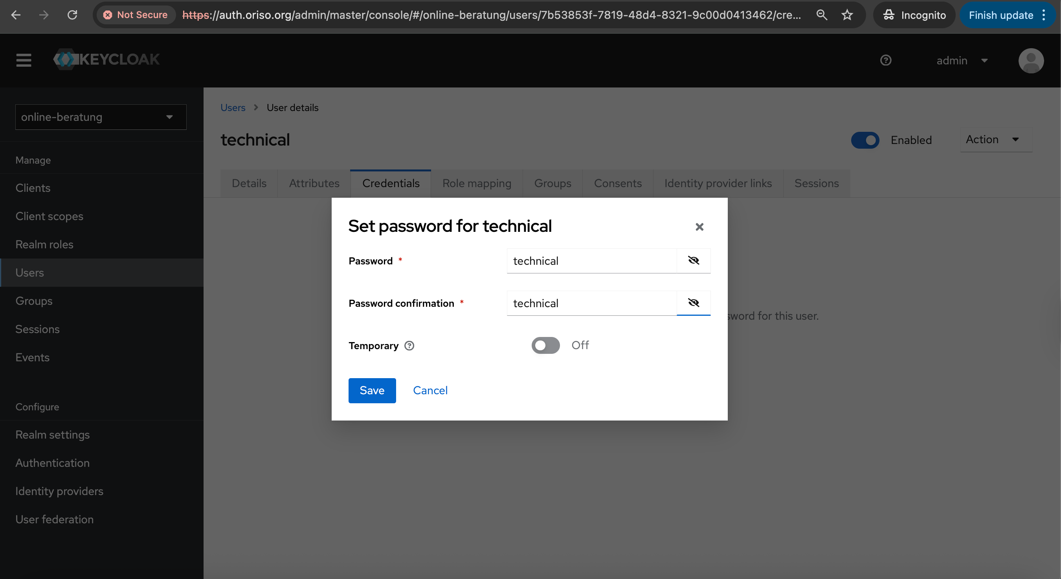
10. Set credentials for the user.

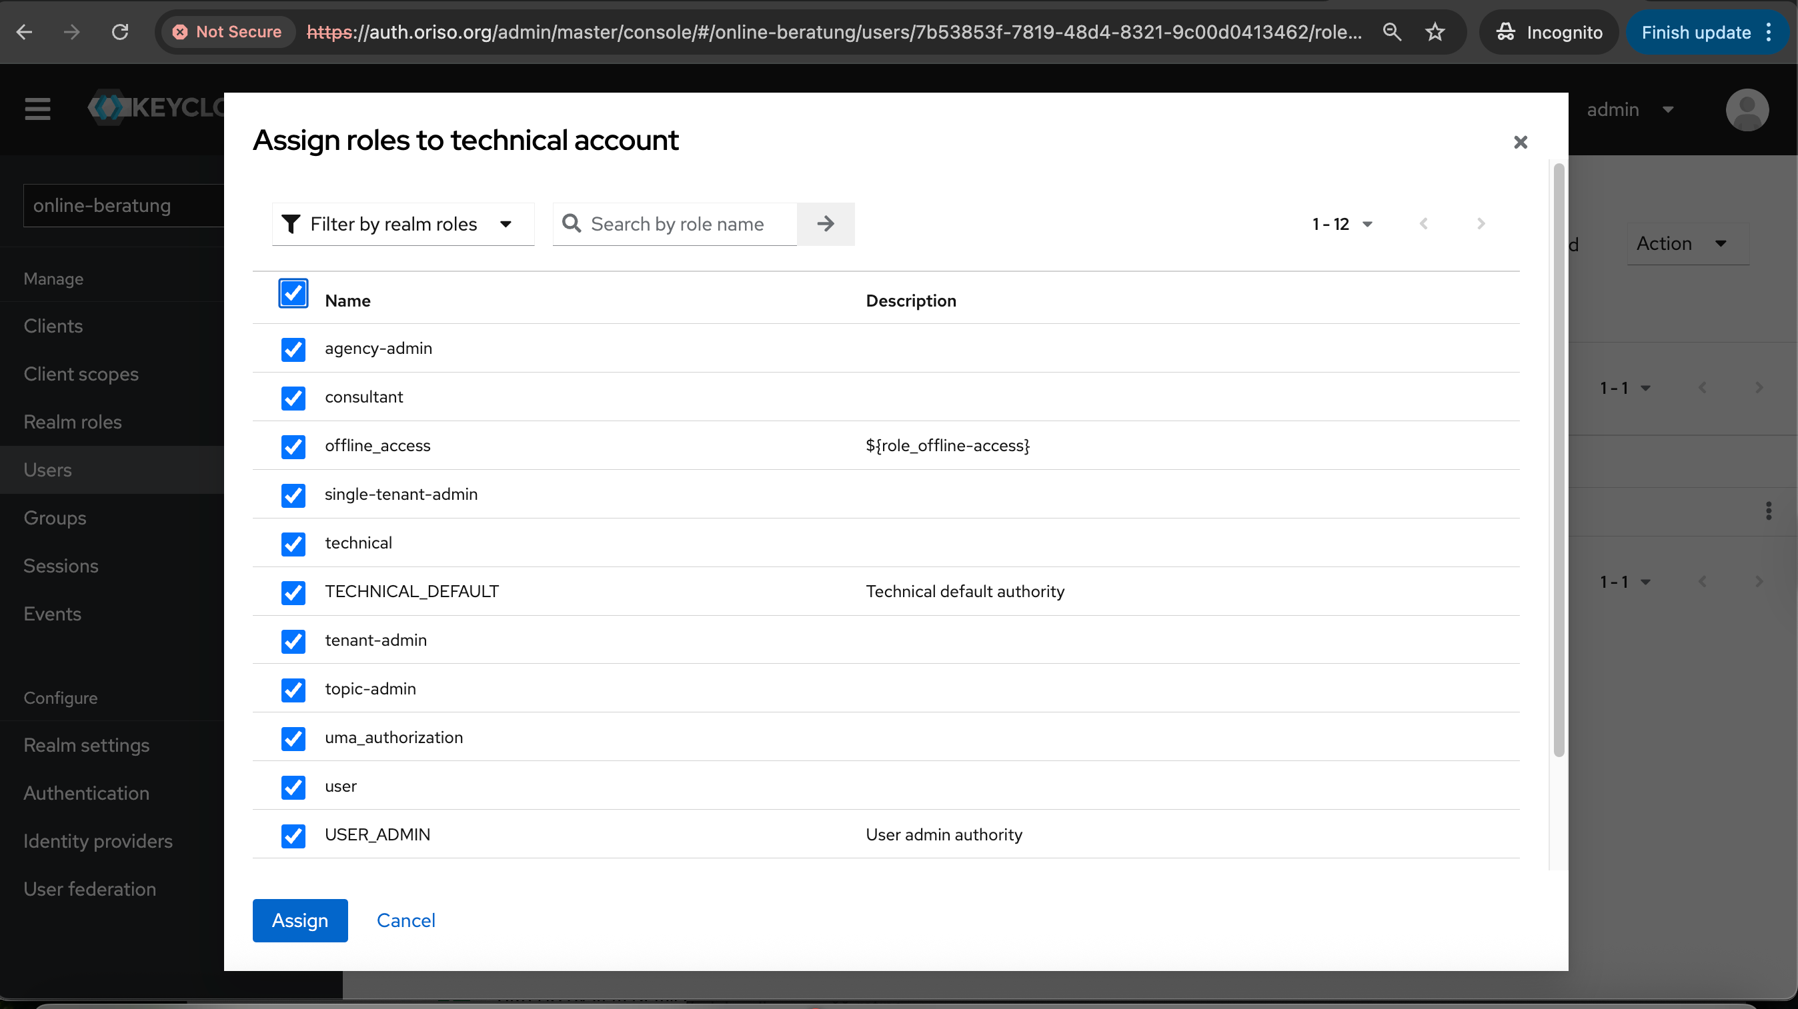
11. In Role mapping, assign required roles to the user.
Select all 12 roles and click Assign.

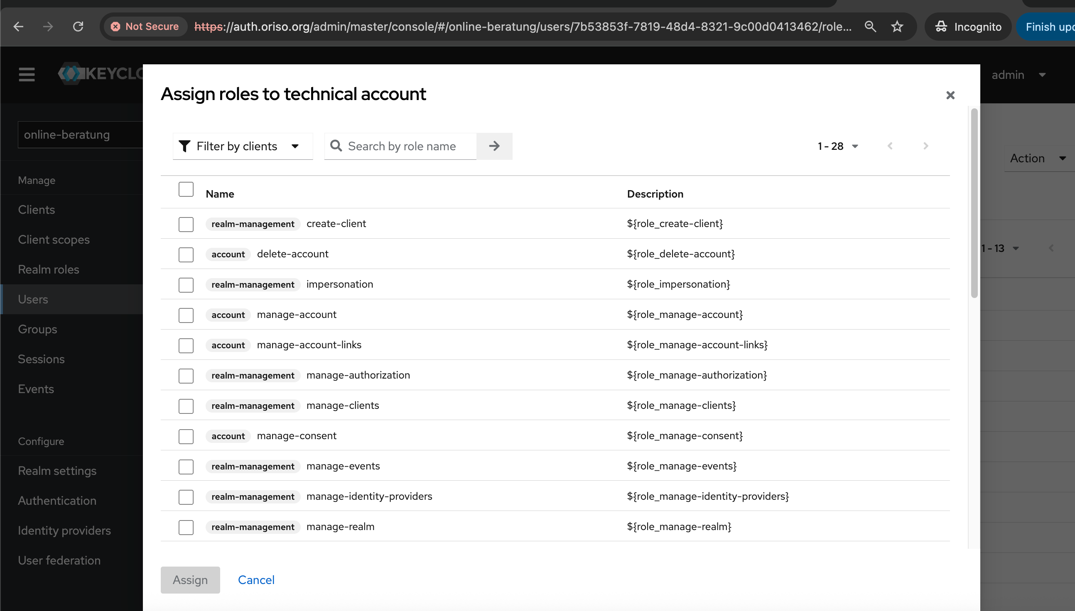
12. Assign client roles to the user.
Use Filter by clients and assign all 28 clients.

Setup complete. You can now log in to ORISO Admin and test user creation and invitation flows.

